
CYBERSTER
NetSec Internship - Week 3 Task Report
Build and Validate a Layer 2 Lab Network
Intern Name: | Muhammad Raza
Instructor Name: | Muhammad Huzaifa Riaz
Company: | CYBERSTER (Batch 2)
Task: | Build and Validate a Layer 2 Lab Network
Date: | 12 July 2026

Table of Contents

Section
1. 3-Switch Topology & VLAN Assignment (Deliverable 1) | 3
1.1 Network Topology Design | 3
1.2 VLAN Database & Subnet Architecture | 3
1.3 Trunk Configuration | 4
1.4 Access Port Assignment | 4
1.5 Router-on-a-Stick Configuration | 5
1.6 PC IP Addressing | 5
2. Cross-Subnet ARP Packet Capture (Deliverable 2) | 6
3. MAC Sticky Behavior Configuration (Deliverable 3) | 7
3.1 Port Security Configuration | 7
3.2 Verification | 7
4. Business Risk Reduction Justification (Deliverable 4) | 8
5. Verification Evidence & Logs (Deliverable 5) | 9
5.1 VLAN Database Verification | 9
5.2 CAM Table / MAC Address Verification | 9
5.3 Connectivity & Ping Verification | 10

1. 3-Switch Topology & VLAN Assignment (Deliverable 1)
A hierarchical Layer 2 topology was engineered using Cisco Packet Tracer to segment organisational traffic across distinct broadcast domains. The architecture utilises one Core/Distribution switch and two Access switches to distribute connectivity to 6 endpoint hosts.

1.1 Network Topology Design
The topology is built in two phases. Phase 1 establishes pure Layer 2 VLAN segmentation. Phase 2 introduces a Cisco 1941 Router for inter-VLAN routing using the Router-on-a-Stick (ROAS) method.
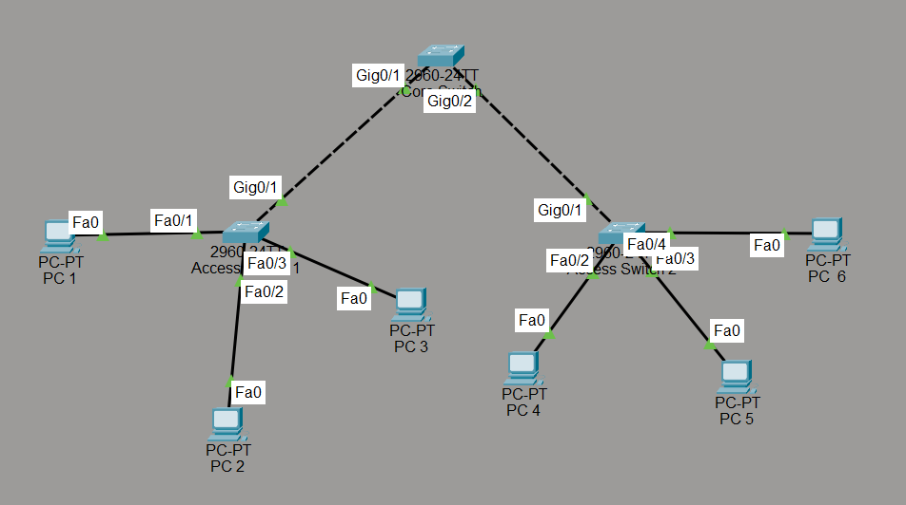
Figure 1a: Phase 1 - Layer 2 segmentation topology (no router).

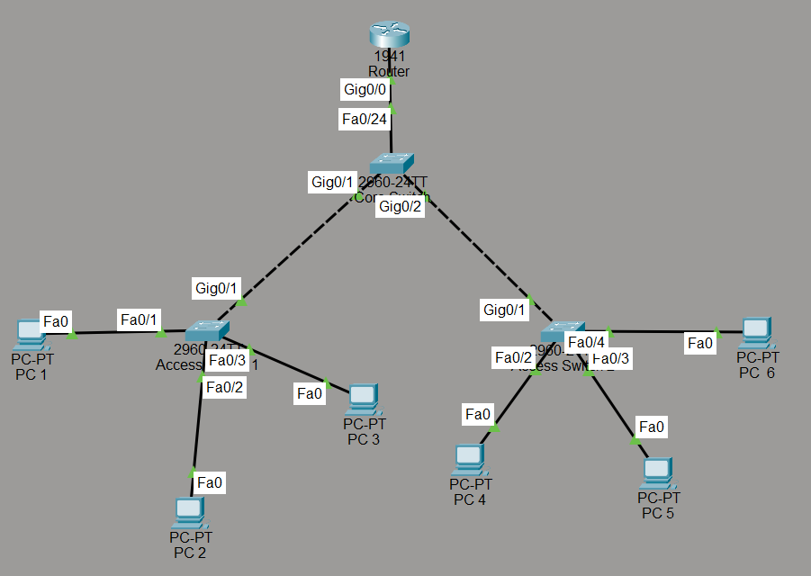
Figure 1b: Phase 2 - Router-on-a-Stick (ROAS) topology added.

1.2 VLAN Database & Subnet Architecture
Four VLANs were created to logically isolate departmental traffic. Each VLAN maps to a unique /24 subnet and is assigned a dedicated sub-interface on the router as its default gateway.

VLAN ID | Name | Subnet | Default Gateway | Hosts
10 | IT_Dept | 192.168.10.0 /24 | 192.168.10.1 | PC 1, PC 5
20 | HR_Dept | 192.168.20.0 /24 | 192.168.20.1 | PC 2, PC 6
30 | Sales_Dept | 192.168.30.0 /24 | 192.168.30.1 | PC 3
40 | Guest_Wifi | 192.168.40.0 /24 | 192.168.40.1 | PC 4

VLANs were created on the Core Switch using the following CLI commands:
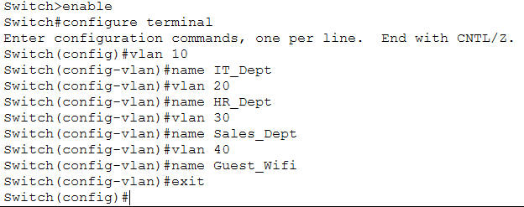
Figure 2a: CLI Commands - creation of VLANs 10, 20, 30, and 40 with department names.

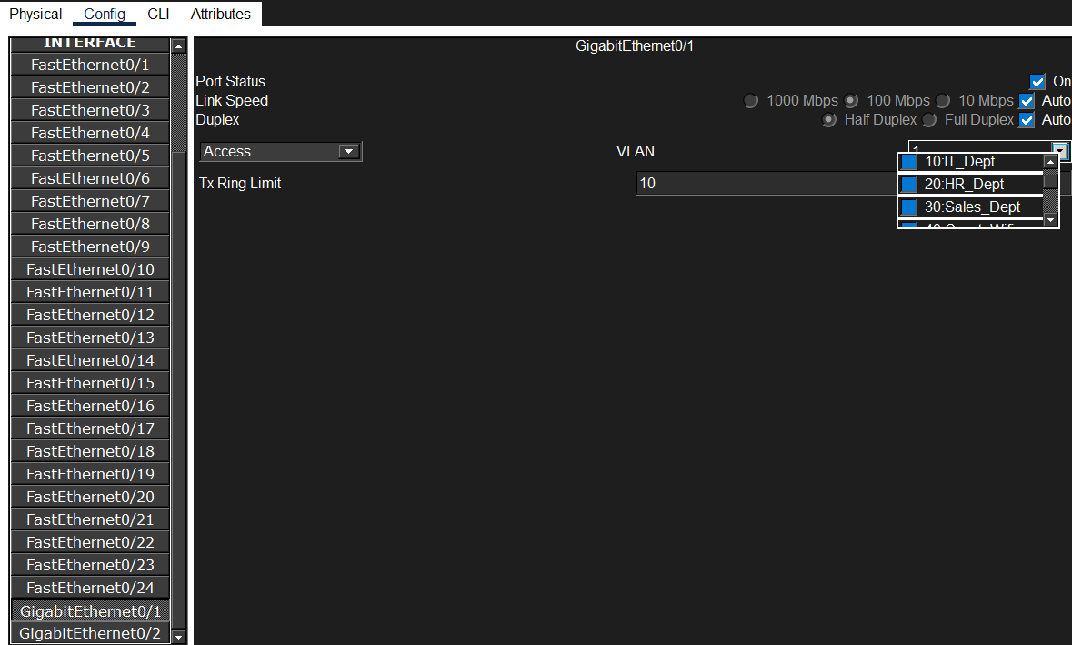
Figure 2b: Core Switch CLI - creation of VLANs 10, 20, 30, and 40 with department names.

1.3 Trunk Configuration
Trunk links carry tagged 802.1Q frames for all VLANs between the Core Switch and both Access Switches. The Core Switch uplink ports (Gig0/1 and Gig0/2) were set to trunk mode. Access Switches also required their uplink ports to be set as trunks.
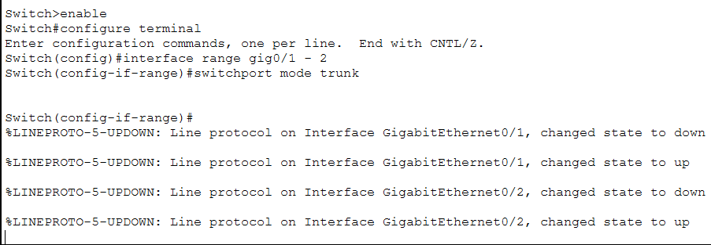
Figure 3a: Core Switch - Gig0/1-2 set to trunk mode (Phase 1).

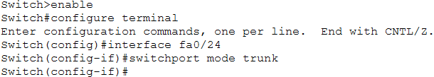
Figure 3b: Core Switch - Fa0/24 set to trunk mode (router uplink, Phase 2).

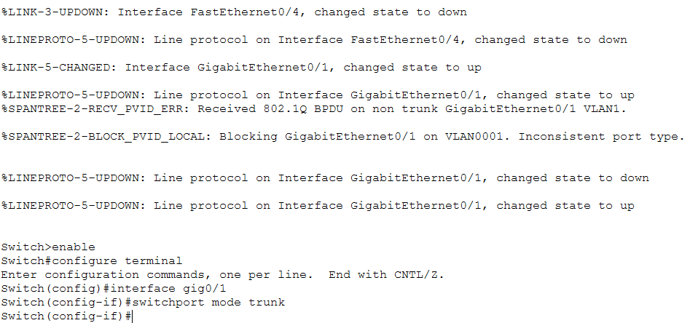

Figure 4: Access Switch uplink Gig0/1 set to trunk mode (PVID error resolved after trunk mode applied).

1.4 Access Port Assignment
Each PC-facing port on the Access Switches was configured as an access port and assigned to the appropriate VLAN. The table below summarises the VLAN-to-port mapping.

Device | Interface → VLAN | Department
Access Switch 1 | Fa0/1 → VLAN 10 | IT_Dept
Access Switch 1 | Fa0/2 → VLAN 20 | HR_Dept
Access Switch 1 | Fa0/3 → VLAN 30 | Sales_Dept
Access Switch 2 | Fa0/2 → VLAN 40 | Guest_Wifi
Access Switch 2 | Fa0/3 → VLAN 10 | IT_Dept
Access Switch 2 | Fa0/4 → VLAN 20 | HR_Dept

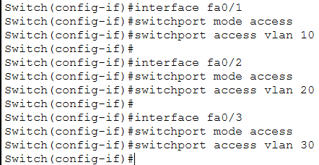
Figure 5a: Access Switch 1 - port access VLAN assignments.
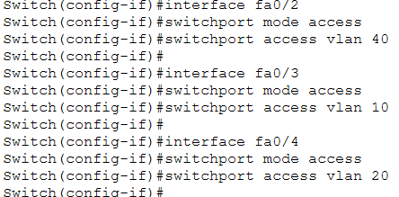
Figure 5b: Access Switch 2 - port access VLAN assignments.

1.5 Router-on-a-Stick (ROAS) Configuration
To facilitate inter-VLAN routing, a Cisco 1941 Router was deployed. Its GigabitEthernet0/0 interface was divided into 802.1Q-encapsulated sub-interfaces, each serving as the default gateway for a respective VLAN. The Core Switch Fa0/24 uplink to the router was set to trunk mode.
Sub-Interface | Encapsulation | IP Address | VLAN
gig0/0.10 | dot1Q 10 | 192.168.10.1 /24 | VLAN 10 - IT_Dept
gig0/0.20 | dot1Q 20 | 192.168.20.1 /24 | VLAN 20 - HR_Dept
gig0/0.30 | dot1Q 30 | 192.168.30.1 /24 | VLAN 30 - Sales_Dept
gig0/0.40 | dot1Q 40 | 192.168.40.1 /24 | VLAN 40 - Guest_Wifi

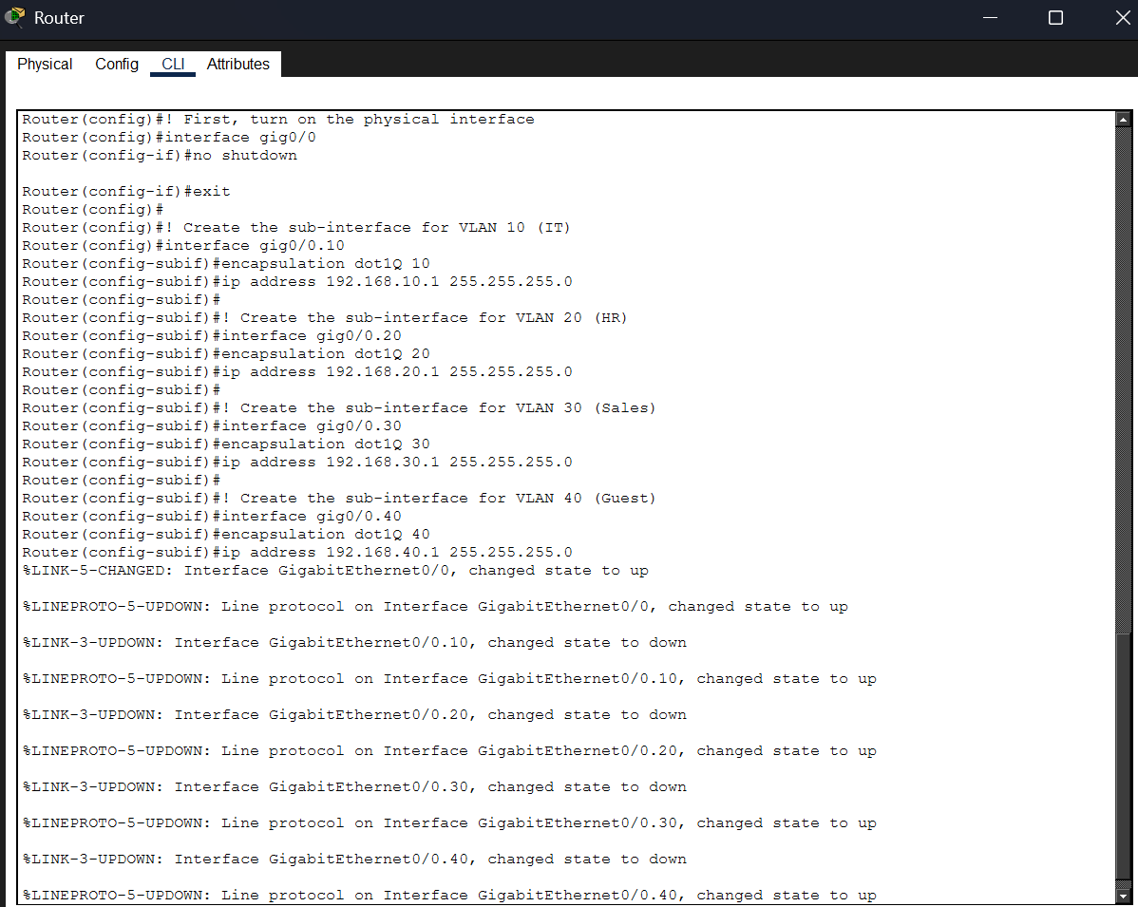

Figure 6: Cisco 1941 Router CLI - sub-interface configuration for all four VLANs with 802.1Q encapsulation.

1.6 PC IP Addressing
All six PCs were statically configured with IP addresses aligned to their respective VLAN subnets. The router sub-interface IP serves as the default gateway for each host.
Host | VLAN | IPv4 Address | Subnet Mask | Default GW | Switch | Port
PC 1 | 10 (IT_Dept) | 192.168.10.10 | 255.255.255.0 | 192.168.10.1 | Access SW 1 | Fa0/1
PC 2 | 20 (HR_Dept) | 192.168.20.10 | 255.255.255.0 | 192.168.20.1 | Access SW 1 | Fa0/2
PC 3 | 30 (Sales_Dept) | 192.168.30.10 | 255.255.255.0 | 192.168.30.1 | Access SW 1 | Fa0/3
PC 4 | 40 (Guest_Wifi) | 192.168.40.10 | 255.255.255.0 | 192.168.40.1 | Access SW 2 | Fa0/2
PC 5 | 10 (IT_Dept) | 192.168.10.11 | 255.255.255.0 | 192.168.10.1 | Access SW 2 | Fa0/3
PC 6 | 20 (HR_Dept) | 192.168.20.11 | 255.255.255.0 | 192.168.20.1 | Access SW 2 | Fa0/4

2. Cross-Subnet ARP Packet Capture (Deliverable 2)
Layer 2 switches cannot route traffic between different subnets. Therefore, for a host in VLAN 10 to communicate with a host in VLAN 20, the originating host must first forward the packet to its Default Gateway (the Router).
To visualise this mechanism, the ARP cache on PC 1 was cleared using arp -d, and an ICMP echo request was initiated toward PC 2 (192.168.20.10). Because PC 1 had no cached hardware address for its gateway (192.168.10.1), it first generated a Layer 2 ARP broadcast.
Step | Event Description
Step 1 - ARP Broadcast | PC 1 sends an ARP Request (Destination: FFFF.FFFF.FFFF) to discover the MAC address of its default gateway 192.168.10.1 (the Router sub-interface).
Step 2 - ARP Reply | The Router replies with its MAC address. PC 1 stores this in its ARP cache.
Step 3 - ICMP via Router | PC 1 encapsulates the ICMP packet in a frame addressed to the Router's MAC. The frame traverses Access Switch 1 → Core Switch → Router.
Step 4 - Inter-VLAN Forwarding | The Router strips the 802.1Q tag, routes the packet to the VLAN 20 subnet, re-encapsulates it with a new VLAN 20 tag, and forwards it toward PC 2.
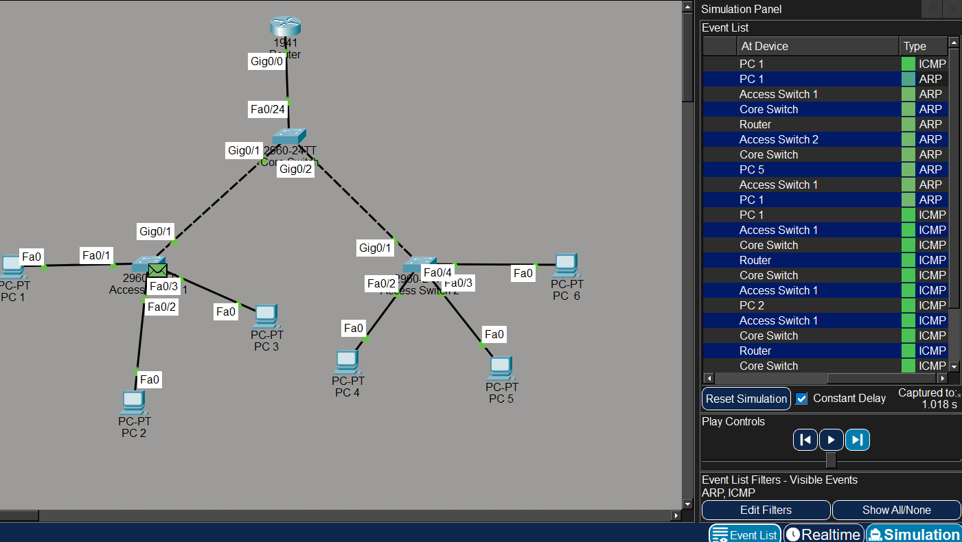
Figure 7: Packet Tracer Simulation Panel - ARP and ICMP event flow across all devices.
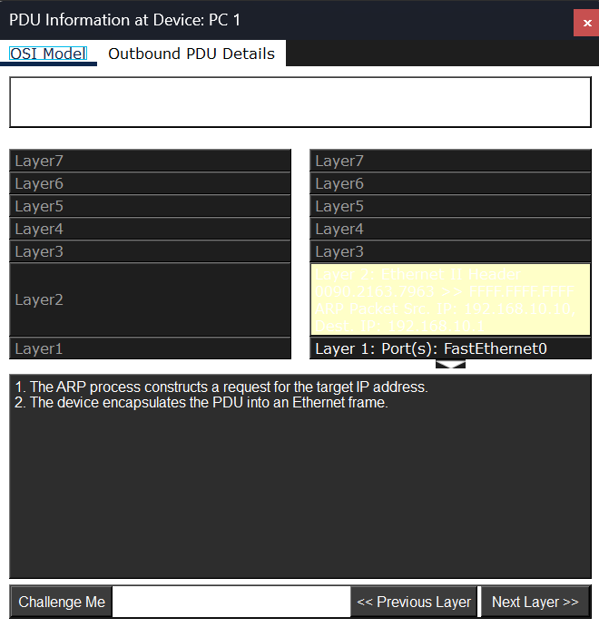
Figure 8: PDU Info at PC 1 - ARP broadcast encapsulated at Layer 2 (FastEthernet0).

3. MAC Sticky Behavior Configuration (Deliverable 3)
To harden the access layer against unauthorised endpoint connections, Port Security with the mac-address sticky feature was implemented on Access Switch 1, specifically on interface FastEthernet0/1 (connected to PC 1).

3.1 Port Security Configuration
The port was first set to access mode (port security does not operate on dynamic/auto ports). It was then configured to dynamically learn and memorise the first MAC address seen, limiting the interface to a maximum of one authorised device. The violation mode was set to Restrict to silently drop unauthorised traffic while keeping the port active.

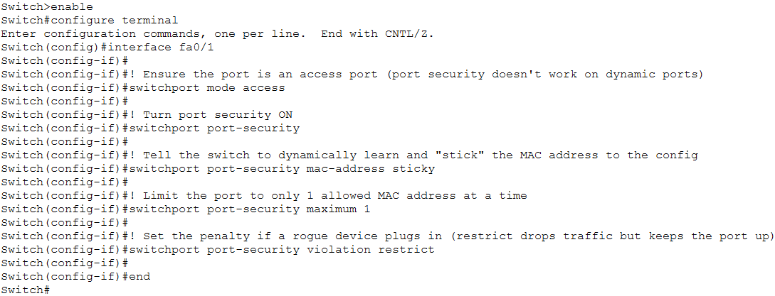

Figure 9: CLI - access mode, MAC sticky, maximum 1 MAC, and restrict violation mode applied on Fa0/1.

3.2 Port Security Verification
Following the configuration, PC 1 generated traffic to trigger the dynamic learning process. The switch successfully bound PC 1's hardware address (0090.2163.7963) to the interface as a STATIC entry.

Parameter | Value / Description
Interface | FastEthernet 0/1 (Access Switch 1)
Port Security | Enabled
Port Status | Secure-up
Violation Mode | Restrict (drops traffic; port stays up; increments counter)
Max MAC Addresses | 1
Sticky MAC | Enabled — dynamically learns and locks the first seen MAC
Learned MAC | 0090.2163.7963 (PC 1)
Violation Count | 0 (no violations recorded)

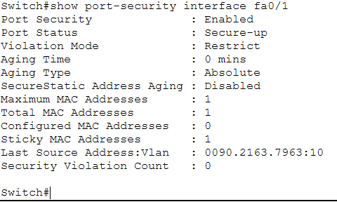

Figure 10: show port-security interface fa0/1 - Port Secure-up, Sticky MAC learned: 0090.2163.7963.

4. Business Risk Reduction Justification (Deliverable 4)
Implementing Port Security with the mac-address sticky feature provides critical mitigation against Layer 2 insider threats and unauthorised physical access. The table below maps specific attack vectors to the protection provided by this configuration.

Threat Vector | Attack Scenario | Port Security Mitigation
Rogue Device Insertion | Attacker unplugs a corporate PC and connects a malicious laptop to pivot into the internal network. | MAC Sticky locks the port to the first learned device. Any rogue device triggers a Restrict violation, dropping its traffic immediately.
MAC Flooding Attack (macof) | Attacker floods CAM table with spoofed MAC entries, forcing the switch into hub mode and broadcasting all traffic. | Max MAC = 1 limit prevents table exhaustion on secured ports. Even if the CAM is flooded elsewhere, port-secured interfaces remain protected.
Unauthorized Physical Access | An insider connects an unauthorized device to a switch port during a security gap. | Sticky MAC with Restrict mode silently blocks the unauthorized device without alerting the attacker, preserving forensic logs via violation counter.

Key Concept: Restrict vs Shutdown Violation Modes

Restrict: Drops traffic from unauthorised MAC. Port stays up. Violation counter increments. Traffic from authorised MAC continues uninterrupted. Preferred for production environments where stealth detection is important.

Shutdown: Immediately err-disables the entire port. Any traffic - including from authorised devices — is blocked until manual intervention (no shutdown). Used in high-security environments with zero tolerance.

5. Verification Evidence & Logs (Deliverable 5)
The logical segmentation and security configurations were validated across the Access and Core layers of the network. The following outputs confirm correct VLAN assignment, MAC learning behaviour, and end-to-end connectivity.

5.1 VLAN Database Verification
The show vlan brief command was executed on the Core Switch and both Access Switches to confirm VLANs 10, 20, 30, and 40 are active and that access ports are correctly mapped to their respective VLANs.

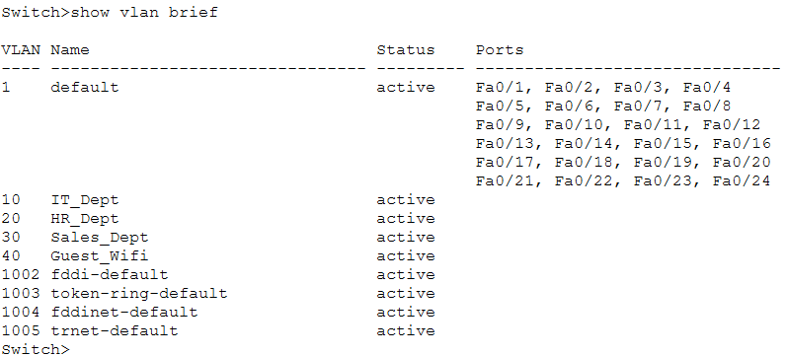
Figure 11a: Core Switch - VLANs 10–40 active, no access ports (all trunk).
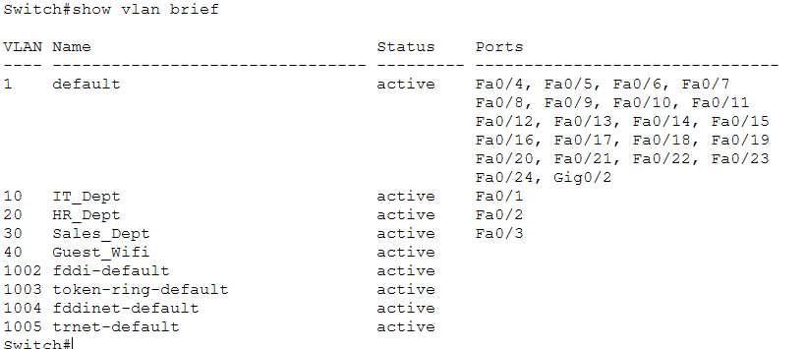
Figure 11b: Access Switch 1 - VLAN 10→Fa0/1, 20→Fa0/2, 30→Fa0/3.
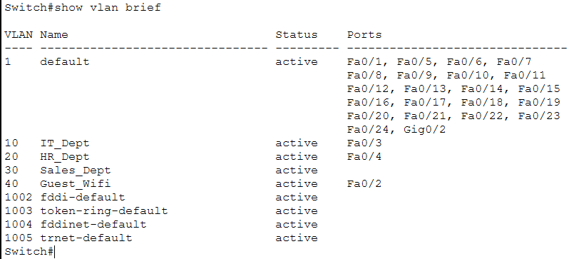
Figure 11c: Access Switch 2 - VLAN 10→Fa0/3, 20→Fa0/4, 40→Fa0/2.

5.2 CAM Table / MAC Address Verification
The show mac address-table command on Access Switch 1 confirms both dynamic and static MAC learning. The secured port Fa0/1 shows the PC 1 MAC as a STATIC entry — a direct result of the Sticky port security configuration. All other ports show DYNAMIC entries as expected.

VLAN | MAC Address | Type | Port / Note
1 | 00e0.a37a.1519 | DYNAMIC | Gig0/1 — Core switch uplink
10 | 0002.1734.da01 | DYNAMIC | Gig0/1 — Learned via trunk
10 | 0090.2163.7963 | STATIC | Fa0/1 — Sticky — PC 1 (port-secured)
20 | 0002.1734.da01 | DYNAMIC | Gig0/1 — Learned via trunk
20 | 0030.a378.0948 | DYNAMIC | Fa0/2 — PC 2 dynamically learned

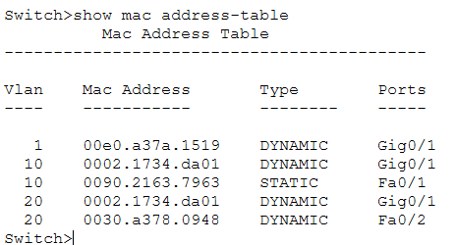
Figure 12: show mac address-table - STATIC entry on Fa0/1 (PC 1, port-secured) vs DYNAMIC entries on trunk and Fa0/2.

5.3 Connectivity & Ping Verification
End-to-end connectivity was validated using ICMP ping tests from PC 1. The intra-VLAN test (PC 1 to its own gateway) achieved 4/4 success. The inter-VLAN test (PC 1 to PC 2 across VLAN 10 → VLAN 20) achieved 3/4 success - the first packet was lost to ARP resolution, with subsequent packets routed successfully with TTL=127.

Source | Destination | Ping Result | TTL | Notes
PC 1 | 192.168.10.1 | 4/4 Success | 255 | Intra-VLAN: PC1 to VLAN 10 gateway
PC 1 | 192.168.20.10 | 3/4 Success | 127 | Inter-VLAN via Router (first pkt=ARP miss)

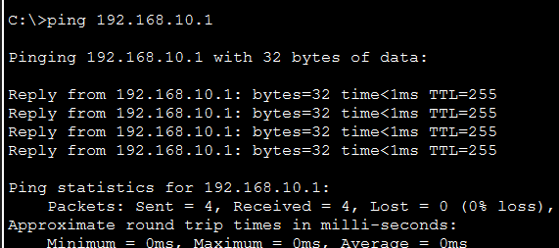
Figure 13a: PC 1 → 192.168.10.1 - 4/4 packets, 0% loss (intra-VLAN gateway).
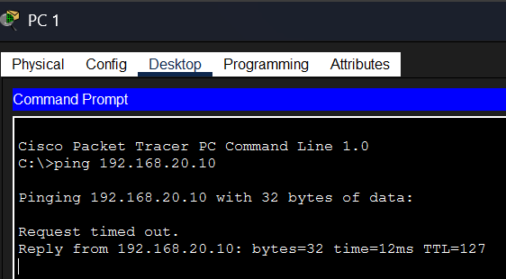
Figure 13b: PC 1 → 192.168.20.10 (PC 2) - inter-VLAN routing via Router, TTL=127.

